Spliting the data into train and test

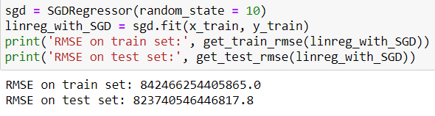

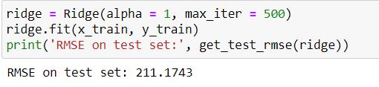

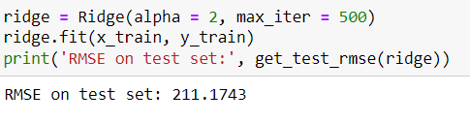

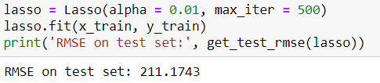

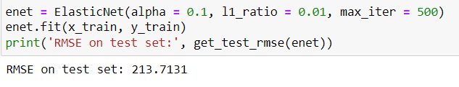

Outputs of Hyper parameter tuning with various models

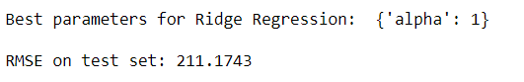

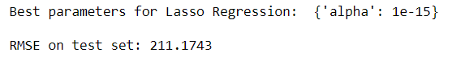



Score card of various models built

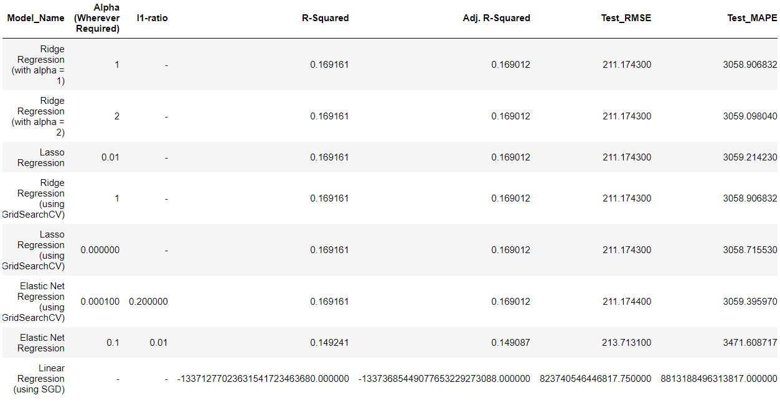

**Inference:** We can see that Lasso Regression (using GridSearchCV) has the lowest test RMSE and test MAPE.

Feature selection using forward selection method

